MGC Interrupt Controller And Programable Interval Timer (ICPIT)

Functional Description
The ICPIT provides a basic interrupt controller functionality together with the capability to implement two timers which can also be configured to generate interrupts. The host bus interface is a 32 bit APB interface.

Interrupt Controller Function
The interrupt controller monitors up to 8 external interrupt lines and 2 internal timer interrupts, sampling their state using the system clock. When a positive edge is detected on an interrupt line, then the interrupt controller latches the corresponding bit in the interrupt status register and raises the interrupt controllers interrupt line. When the interrupt status register is read, any set interrupt status bits are cleared and the interrupt line goes low.
Each interrupt input can be disabled or enabled via a bit in the interrupt enable register.
The interrupt controller also generates an interrupt from the Watchdog timer, this interrupt is not maskable via the interrupt enable register.

Timer Functions
There are two timers available, one is intended as a programmable interval timer and the other as a watchdog timer.
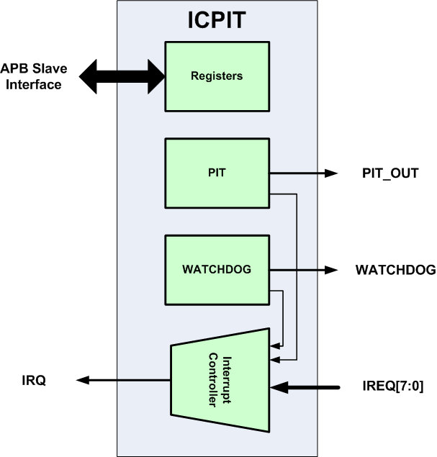
ICPIT Functional block diagram

Programmable Interval Timer (PIT)
The PIT loads the value set in the PIT count register and counts down on each positive edge of the system clock (PCLK). When the terminal count is reached, the PIT generates a time-out pulse which is one clock wide and then reloads the count register value on the next clock edge.
The PIT is enabled and disabled via the PIT enable bit in the PIT control register. The PITs current count value can be read back from the PIT current count register.

Watchdog Timer
The purpose of the Watchdog Timer is to provide a Watchdog function. It is implemented as a counter that counts down from 32’h4200_0000, starting from the end of reset (PRESETN). Once the watchdog reaches the zero terminal count, then it generates an interrupt.
The Watchdog Timer can be reloaded by writing a 1 to the Watchdog bit in the PIT control register, this bit is self-clearing and will be read back as a zero. The state of the Watchdog Timer cannot be read back.

Interface Port Description
The interface signal ports for the IPIT are detailed in the following table:
Port | Width | Direction | Description
PCLK | 1 | Input | APB System Clock
PRESETN | 1 | Input | APB Synchronous Reset – Active Low
PADDR | 3 | Input | APB Address
PSEL | 1 | Input | APB Peripheral Select
PENABLE | 1 | Input | APB Peripheral Enable
PWRITE | 1 | Input | APB Write Enable
PWDATA | 32 | Input | APB Write data
PRDATA | 32 | Output | APB Read data
PREADY | 1 | Output | APB Peripheral ready
IRQ | 1 | Output | Interrupt to host
IREQ | 8 | Input | Interrupt request inputs
PIT_OUT | 1 | Output | PIT terminal count flag
WATCHDOG | 1 | Output | Watchdog terminal count flag

Register Description
All the registers are read as 32 bit values and they are written to with a 32 bit value. Any unused bits will be read back as zeros and any writes to unused bits will have no effect.

Register Address Table:
Name | Address | Width | Access | Description
Interrupt Enable | Base + 0x0 | 10 | RW | Interrupt Enable Register
Interrupt Status | Base + 0x4 | 10 | R | Interrupt Status Register
PIT Count | Base + 0x8 | 32 | RW | PIT Count value
PIT Current Count | Base + 0xc | 32 | RW | Current state of the PIT counter
PIT Control | Base + 0x10 | 2 | RW | PIT and Watchdog control

Interrupt Enable Register Description
The interrupt enable register enables interrupts coming from the interrupt request inputs or the PIT terminal count. The Watchdog interrupt cannot be masked.
Bit | Access | Reset | Description
7:0 | R/W | 0x0 | INTE  Interrupt enables for each of IREQ lines
8 | R/W | 0x0 | PITE  Interrupt enable for the PIT terminal count interrupt
9 | R | 0x1 | WDOGE  Watchdog Interrupt enable – always enabled
Reset Value: 0x0000_0200

Interrupt Status Register Description
The interrupt status register indicates which interrupt(s) sources are currently active. When a status bit is read back as a ‘1’, then it is reset to a ‘0’. If multiple edges occur on an interrupt line between host interrupt service routines, there is no storage of the interrupt events, the interrupt status bit is set by the first occurrence.
Bit | Access | Reset | Description
7:0 | R | 0x0 | IREQ  IREQ input interrupt event has occurred
8 | R | 0x0 | PIT  PIT terminal count interrupt
9 | R | 0x0 | WDOG  Watchdog Interrupt
Reset Value: 0x0000_0000

PIT Count Register Description
The PIT count register contains the count which is used by the PIT to count down from. Writing a value of 0 to the register will result in a permanent reload state
Bit | Access | Reset | Description
31:0 | R/W | 0x0 | COUNT  The PIT counts down from the value written to this field
Reset Value: 0x0000_0000

PIT Current Count Register Description
The PIT Current Count returns the value of the PIT counter at the point at which the register is read back.
Bit | Access | Reset | Description
31:0 | R | 0x0 | COUNT  The current PIT count value
Reset Value: 0x0000_0000

PIT Control Register Description
The PIT control register controls the enabling of the PIT and the reload of the Watchdog timer counter. The desired PIT count value should be loaded before the PIT is enabled.
A transition from not enabled to enabled will cause the PIT to be reloaded with the value in the PIT count register.
Bit | Access | Reset | Description
0 | R/W | 0x0 | PIT_ENABLE  ‘1’ – PIT counter is enabled  ‘0’ – PIT counter is disabled
1 | W | 0x0 | WATCHDOG_BONE  ‘1’ – Reloads the Watchdog Timer  ‘0’ – Has no effect
Reset Value: 0x0000_0000

